 | BOW TIE | 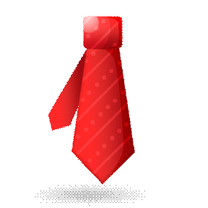 | NECK TIE
 | BASEBALL HAT/CAP |  | SOCKS
 | FLIP FLOPS |  | SNEAKERS  (CONVERSE)
 | HIKING BOOTS |  | COWBOT HAT
 | SCARF |  | SANDALS
 | BUTTON DOWN SHIRT |  | COWBOY BOOTS
 | HIGH HEEL SHOES  (HIGH HEELS) | 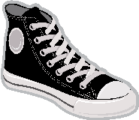 | HIGH TOP  SNEAKERS  (HIGH TOPS)
 | SLIPPERS |  | T-SHIRT
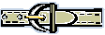 | BELT |  | TWO PIECE BATHING SUIT
 | DRESS SHOES |  | POLO SHIRT
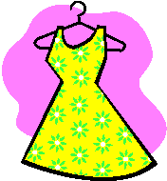 | DRESS |  | SHORTS
 | JEANS |  | PANTS
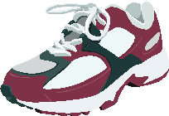 | RUNNING SHOES  -OR-  SNEAKERS | 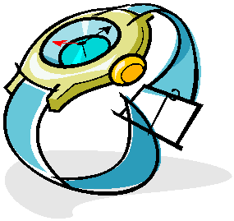 | WATCH
 | RING |  | NECKLACE
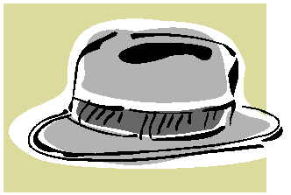 | HAT |  | LAUNDRY BASKET
 | ONE PIECE BATHING SUIT |  | WINTER HAT
 | BIKINI |  | TANK TOP
 | JACKET |  | SUIT
 | GLOVES |  | SWEATER
 | BRACELET | 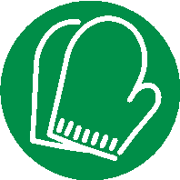 | MITTENS
 | EYEGLASSES | 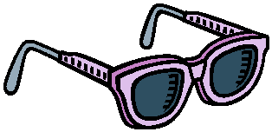 | SUNGLASSES
 | SKIRT |  | MINI SKIRT
 | COAT |  | CLOSET
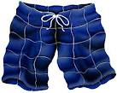 | SWIM TRUNKS

