Clothing Quiz
Say 10 and Write 10

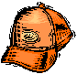 ______________
______________
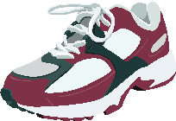 _____________
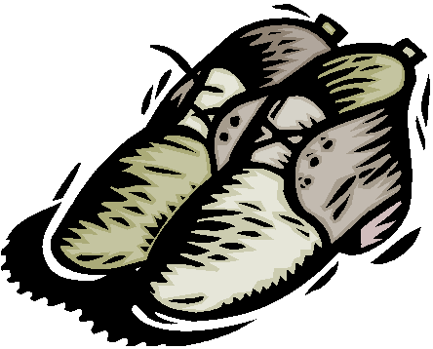 _____________
 ______________
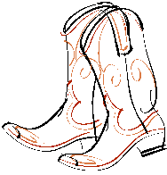 _____________
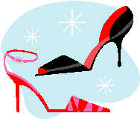 _____________
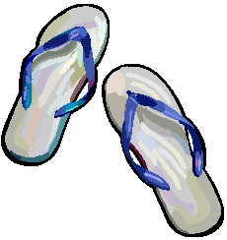 ______________

 _______________
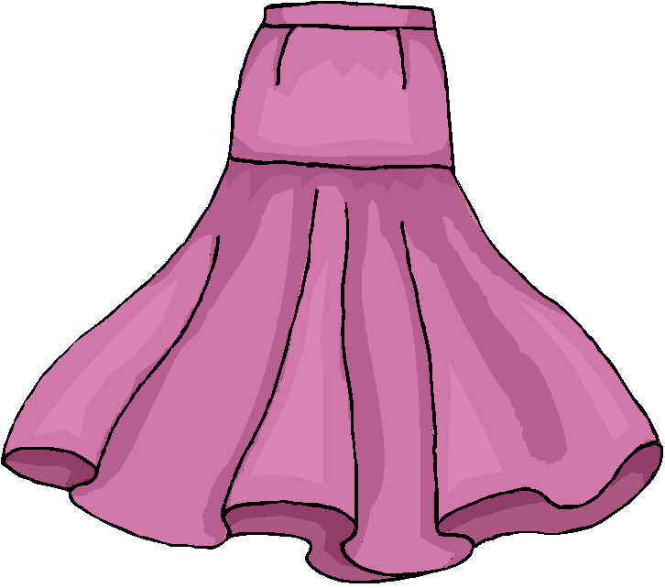 _______________
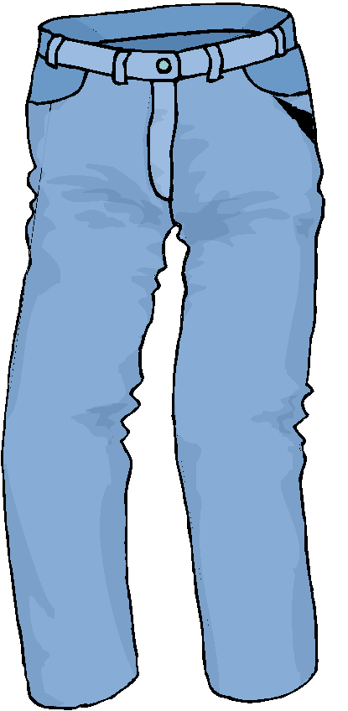 ________________
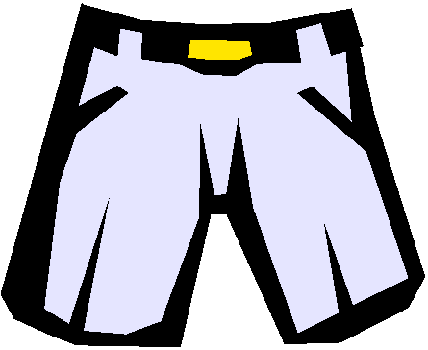 ______________
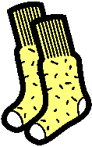 ________________
 _____________
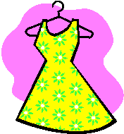 ______________

________________

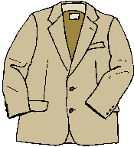 ________________
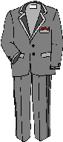 __________________
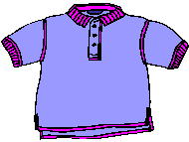_______________
________________
_______________
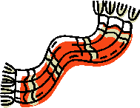 _______________
______________
It’s rainy - circle the clothing for rainy weather

 ______________
 __________________
________________
It’s sunny - circle the clothing for sunny weather

 ________________
Draw and color what she is wearing

She is wearing black boots, blue jeans, a belt, a red t-shirt, a yellow scarf, sunglasses and a green baseball hat.

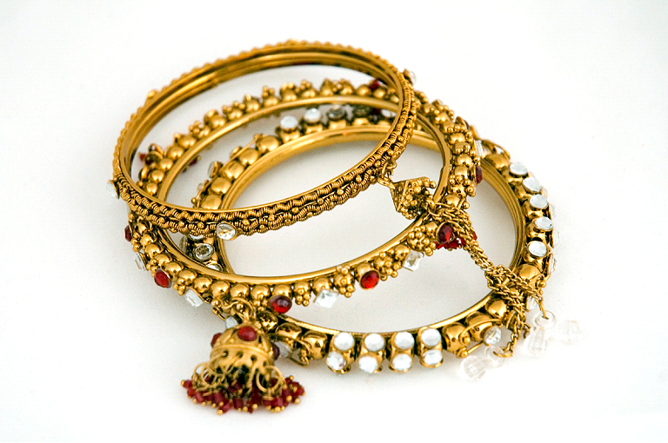 _____________

 ______________
Circle the correct answer
The flip flops are grey and uncomfortable.
The socks are wool and warm.
The slippers are soft and casual.
The dress shoes are dressy and leather.

 _____________

_____________

 

